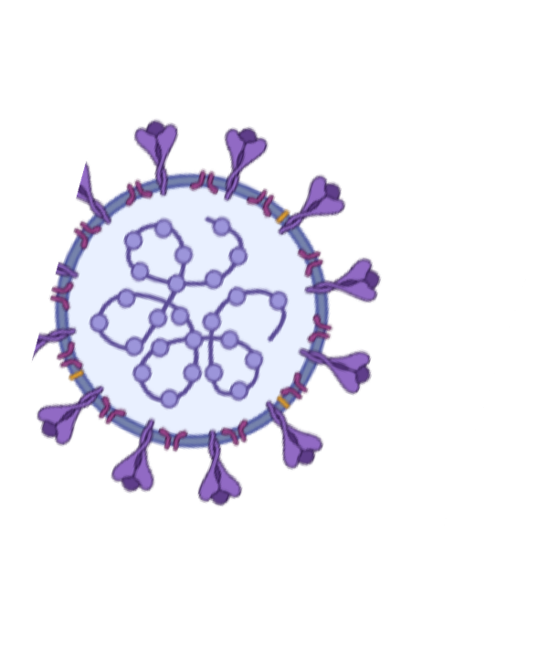
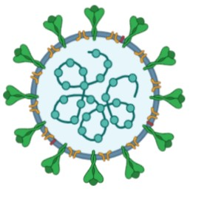
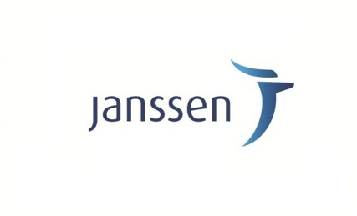

What is the Patient care proposal for blood cancers during SARS-CoV-2 viral pandemic (PREPARE) project?

The PREPARE project aims to understand the risk COVID-19 poses for patients with blood cancers using information in the RUDY study. The first wave of the project will focus on myeloma patients who have joined the RUDY study. The information collected will help healthcare professionals and patients work together to balance the potential risk of COVID-19 and blood cancer management appropriately.
·
The PREPARE project aims to answer the following questions:
- Are blood cancer patients at greater risk of severe COVID- 19 disease ?
- Do blood cancer patients mount an immune response to COVID-19 and is this response sustained over time?
- Do patients with blood cancer gain immunity with COVID-19 vaccination?
- Should blood cancer treatment be altered to optimise COVID-19 vaccine immunity?

What is the link between the RUDY and PREPARE?
The RUDY research study is interested in understanding all aspects of rare conditions, including myeloma. RUDY has already recruited over 500 myeloma (blood cancer) patients in the 2 years it has been open (https://research.ndorms.ox.ac.uk/rudy/). The PREPARE project aims to answer specific questions within the RUDY study.

Study investigators include:
Dr Karthik Ramasamy, together with colleagues at Oxford University Hospitals NHS Foundation Trust, working in close collaboration with the RUDY study team at University of Oxford (Dr Kassim Javaid and Dr Ross Sadler).

To Find out more :
@PrepareStudy
  - Go to www.rudystudy.com and click on “Find out more”
  - Read the patient information sheet in the “Library”
  - If you want to take part in the RUDY study you can do this online by clicking the green "Join us now" button

Follow the steps and you will soon be able to share your data with researchers focused on improving care for patients with myeloma

If there are any questions you can’t find answers to then please send us an email admin@rudystudy.org or call us on 07775 541615 / 01865 223407 and we will get back to you
RUDY PREPARE LEAFLET V1 01/12/2020 REC:17/SC/0501 IRAS: 21370

